1. What is the value of x after the code executes?

* var x;  
  x = 5;  
  var x = 10;
  + 1. 5
    2. 10
    3. Undefined
    4. Error

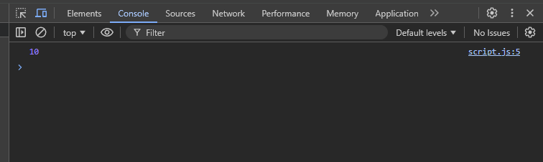

1. What is the output of the following code?

* console.log(x);  
  var x = 15;
  + 1. 15
    2. Undefined
    3. ReferenceError
    4. Null

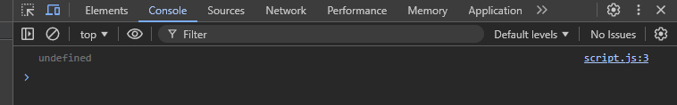

1. How many times is the variable y redeclared in this code?

* var y = 1;   
  var y = 2;   
  y = 3;
  + 1. 1
    2. 2
    3. 3
    4. 0

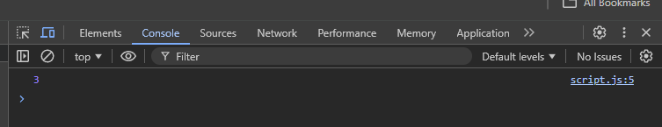

1. What happens when you declare a var variable without initializing it?

* var b;  
  console.log(b);
  + 1. Null
    2. Undefined
    3. Error
    4. 0

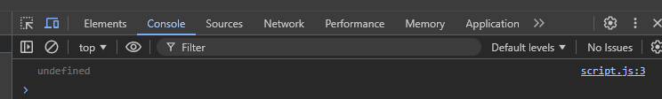

1. What will the following code print?

* var a = 1;  
  {  
   var a = 2;  
  }  
  console.log(a);
  + 1. 1
    2. 2
    3. Undefined
    4. Error

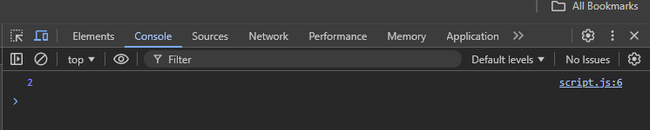

1. What happens when you declare a var variable inside a block and access it outside?

* {  
   var c = 10;  
  }  
  console.log(c);
  + 1. Error
    2. Undefined
    3. 10
    4. Null

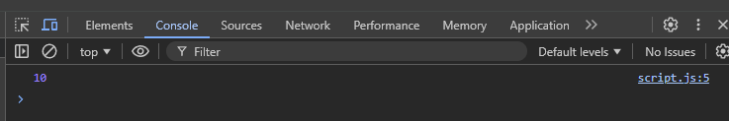

1. What is the output of the following code?

* var p;  
  console.log(p);  
  p = 20;
  + 1. Undefined
    2. 20
    3. Null
    4. Error

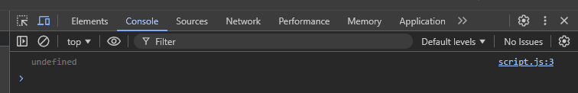

1. What happens if you declare a var variable and later redeclare it in the same scope?

* var q = 5;   
  var q = 10;   
  console.log(q);
  + 1. 5
    2. 10
    3. Error
    4. Undefined

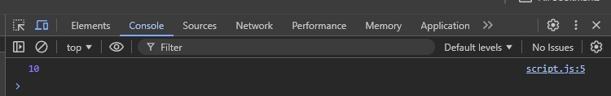

1. What is the value of r after this code executes?

* var r;  
  r = 30;  
  var r = 50;
  + 1. 30
    2. 50
    3. Undefined
    4. Error

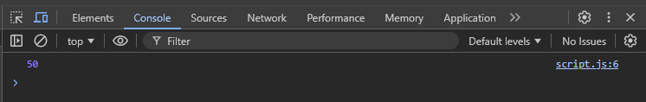

1. What will this code output?

* console.log(x);  
  var x = 25;
  + 1. Undefined
    2. 25
    3. Error
    4. Null

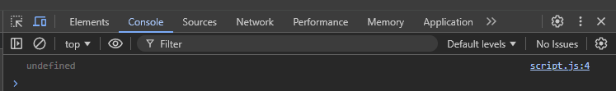

1. What happens if you try to access a var variable before declaring it?

* console.log(a);  
  var a = 40;
  + 1. Undefined
    2. ReferenceError
    3. 40
    4. Null

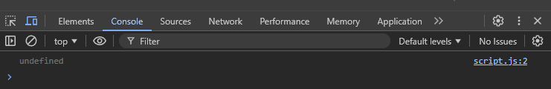

1. What happens in this code?

* var t = 10;   
  var t;   
  console.log(t);
  + 1. Undefined
    2. 10
    3. Error
    4. Null

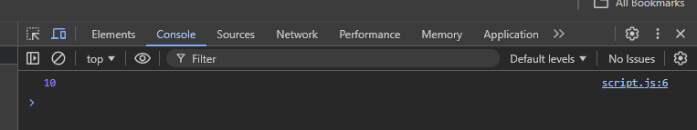

1. What happens if you assign a value to a var variable before declaring it?

* x = 100;   
  var x;   
  console.log(x);
  + 1. 100
    2. Undefined
    3. Error
    4. Null

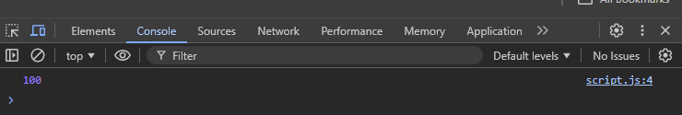

1. What happens when you declare a var variable twice in a global scope?

* var y = 5;   
  var y = 10;
  + 1. Error
    2. Redefines the value
    3. Ignored second declaration
    4. None of the above

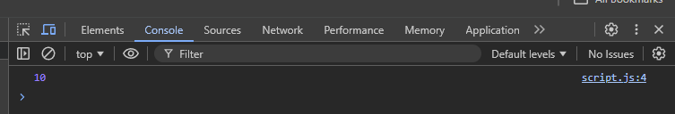

1. What is the output of this code?

* var z = 1;   
  z = 2;   
  console.log(z);
  + 1. 1
    2. 2
    3. Undefined
    4. Error

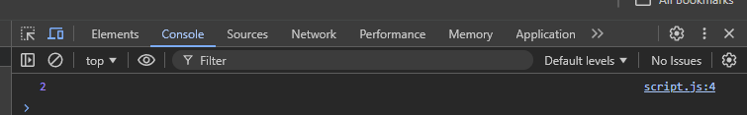

1. What is the value of _Xyz12$ in this code?

* var _Xyz12$;  
  _Xyz12$ = 45;  
  console.log(_Xyz12$);
  + 1. Undefined
    2. 45
    3. Error
    4. Null

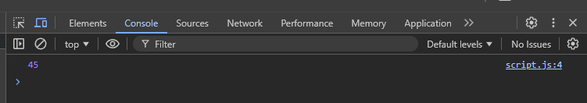

1. What will this code output?

* var $num_Val = 8;   
  $num_Val = 16;   
  console.log($num_Val);
  + 1. 8
    2. 16
    3. Undefined
    4. Error

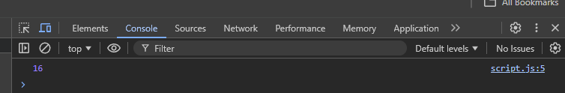

1. What happens in this code?

* console.log(_x_Val12);   
  var _x_Val12 = 27;
  + 1. Undefined
    2. 27
    3. Error
    4. Null

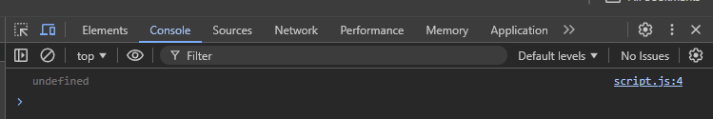

1. What is the final value of Val_12X$?

* var Val_12X$ = 10;   
  Val_12X$ = 20;   
  console.log(Val_12X$);
  + 1. 10
    2. 20
    3. Error
    4. Null

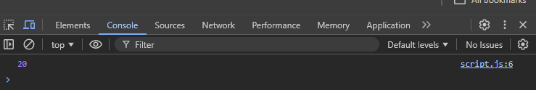

1. What happens here?

* console.log(VAL_num);   
  var VAL_num = "Test";
  + 1. Undefined
    2. Test
    3. Error
    4. Null

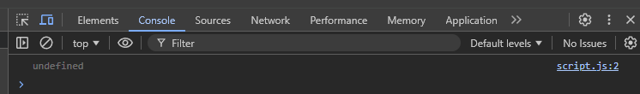

1. What does this code print?

* var $count = 5;   
  $count = $count + 3;   
  console.log($count);
  + 1. 5
    2. 8
    3. Undefined
    4. Error

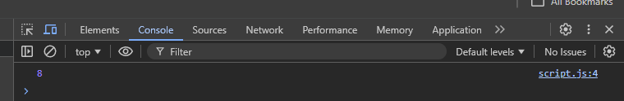

1. What is the result of this code?

* var _alpha$ = 50;   
  var _alpha$ = 100;   
  console.log(_alpha$);
  + 1. 50
    2. 100
    3. Error
    4. Undefined

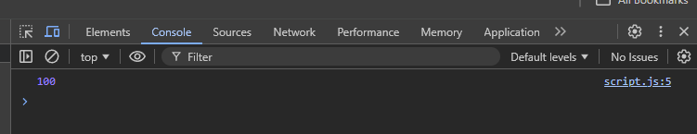

1. What happens in this code?

* var A1b_2$ = 1;   
  console.log(A1b_2$);
  + 1. 1
    2. Undefined
    3. Error
  1. Null

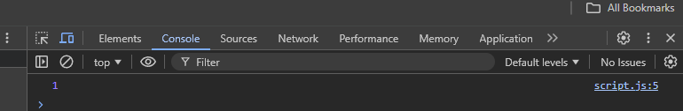

1. What does this print?

* var $$$ = 99;   
  $$$ = 88;   
  console.log($$$);
  + 1. 99
    2. 88
    3. Undefined
    4. Error

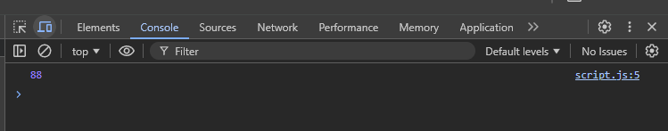

1. What is the output of this code?

* var _vA_rX = "Code";   
  console.log(_vA_rX);
  + 1. Undefined
    2. Code
    3. Error
    4. Null

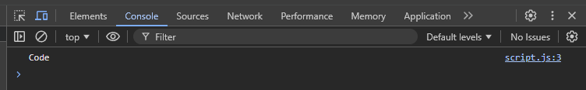

1. What happens when this executes?

* var X_$12;   
  console.log(X_$12);   
  X_$12 = 123;
  + 1. Undefined
    2. 123
    3. Error
    4. Null

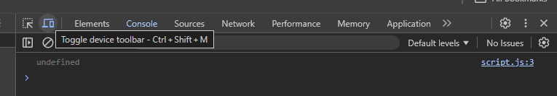

1. What is the behavior of __X_var$ in this scenario?

* var __X_var$ = "Hello";   
  var __X_var$ = "World";   
  console.log(__X_var$);
  + 1. Hello
    2. World
    3. Error
    4. Undefined

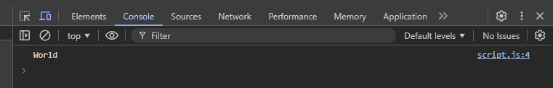

1. What will this output?

* var VaR_$$ = "Testing";   
  console.log(VaR_$$);
  + 1. Undefined
    2. Testing
    3. Error
    4. Null

1. What happens here?

* console.log($$$Alpha);   
  var $$$Alpha = 55;
  + 1. Undefined
    2. 55
    3. Error
    4. Null

1. What is the final value of 12x$var_?

* var 12x$var_ = 100;   
  console.log(12x$var_);
  + 1. 100
    2. Undefined
    3. Error
    4. Null